SQL Homework 2 – Daniel Werminghausen

1a.) The image of O’s and X’s is displayed on the website with image tags. By looking at the source code I found the image tags displaying O’s and X’s

<img src="x.gif" alt="[X]" width="40" height="42">

<img src="o.gif" alt="[O]" width="40" height="42">

1b.)

<INPUT BORDER=0 NAME=0 TYPE=IMAGE WIDTH=40 HEIGHT=42 SRC="blank.gif"> There are 9 of these for each square in tik tak toe. This command tells the website which square was clicked. There are

1c.) Client-server rounds trips that are needed to display the page:

One trip for index page and the other 3 trips for O.gif, X.gif and blank.gif.

1d.) When hovering over an HTML element it defines the shape of the cursor

1e.) the X’s and O’s are kept in: <INPUT NAME=BOARD TYPE=HIDDEN VALUE=O---X--XO > the response of this is computed by the server.

1f.) This webpage does not display HTML5, there is no CSS on this webpage. This webpage is super simple and old.

2.)

<!DOCTYPE html>

<html>

<head>

<title>User Registration</title>

</head>

<body>

<h1>Register for the Website</h1>

<form>

<h3>Name</h3>

<input type="text" name="name" value="name"><br>

<h3>Email Adress</h3>

<input type="email" name="Preferred email" value="Preferred Email">

<br>

<input type="submit" name="Submit">

</form>

</body>

</html>

Question 2b.)

Using CSS, I would be able to space out the boxes nicely and align everything to make it looks nicer Also we can make the button work for submit. right now, plugging something into the name and email and hitting submit is not doing anything

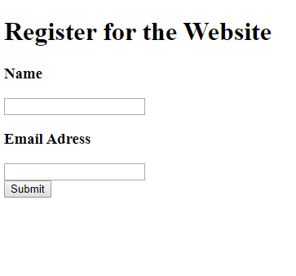

3.) Setup NetBeans successfully and downloaded free packets from Murach/ projects added to Netbeans

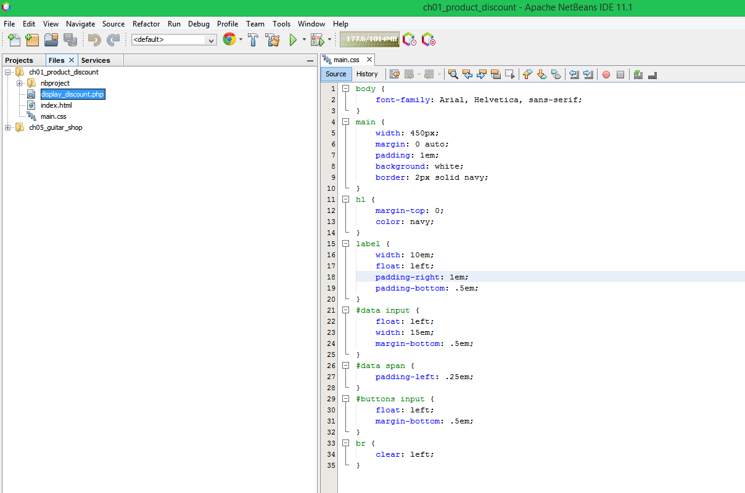

This is the outcome of the product discount calculator running it on chrome:



4.) The new HTML and CSS that I put together is from ch01_product_discount The HTML code is basically the same except change the submit to calculate discount. For the CSS a couple more changes but almost the same as before.

<!DOCTYPE html>

<html>

<head>

<title>Product Discount calculator</title>

<link rel="stylesheet" type="text/css" href="main.css">

</head>

<body>

<main>

<h1>Product Discount Calculator</h1>

<form action="display_discount.php" method="post">

<div id="data">

<label>Product Description</label>

<input type="text" name="product_description"><br>

<label>List Price</label>

<input type="name" name="list_price"><br>

<label>Doiscount Percent</label>

<input type="text" name="discount_percemt"><span>%</span><br>

</div>

<div id="buttons">

<label>&nbsp;</label>

<input type="submit" value="Calculate Discount"><br>

</div>

</form>

</main>

</body>

</html>

----------------------------------------------------------------------------------

body {

font-family: Arial, sans-serif;

font-weight: bold;

}

main {

width: 900px;

margin: 0 auto;

padding: 2em;

background: lightblue;

border: 3px solid black;

}

h1 {

color: red;

}

label {

float: left;

width: 10em;

padding-right: 1em;

padding-bottom: .5em;

}

#data input {

float: left;

width: 15em;

margin-bottom: .5em;

}

#data span {

padding-left: .25em;

}

#buttons input {

float: left;

margin-bottom: .5em;

}

br {

clear: left;

}

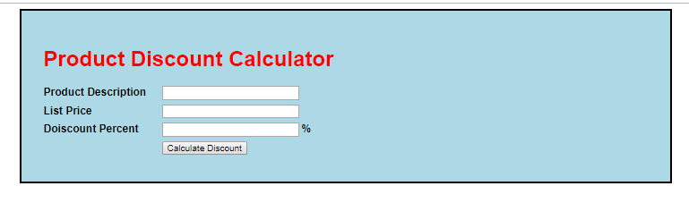

4b.) This is how it looks on internet Explorer: Its definitely not reading the CSS as we would want it to.

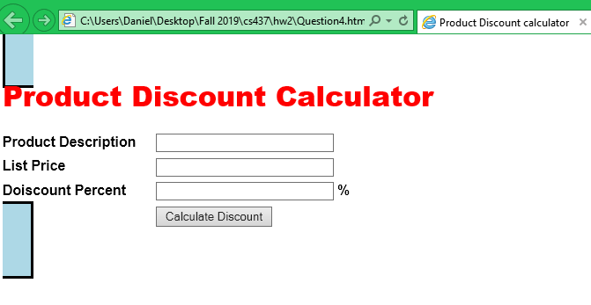

Internet Explorer version: 11.0.9600.18450

5a.) On the full screen on windows we can see three stories shown and a bar on the right side with other stories vs my phone showing 2 stories total. 3 big images and 6 small images on the chrome on my laptop and 2 columns while on my phone there is only one column and one image and one story and another story that Is cut off.

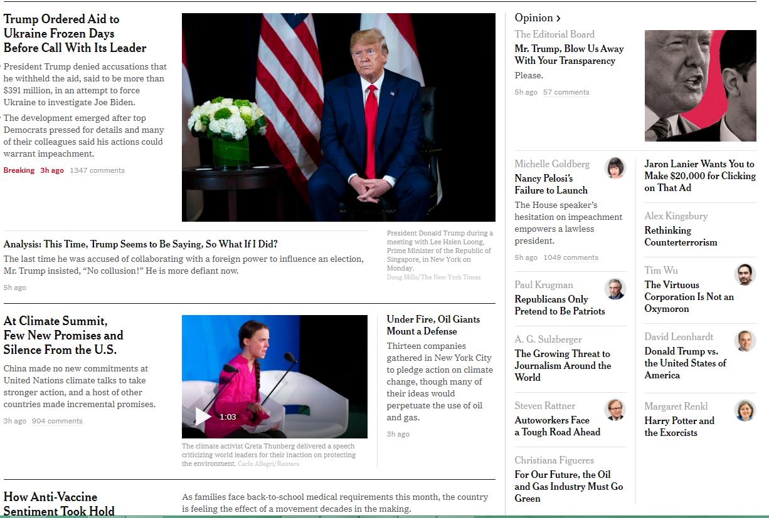

5b.) I can see the menu on the full screen chrome tab with option “world” on top, so it just needs one click. From the phone I need to scroll up and go the hamburger with the three horizontal bars and it will show a drop-down menu and I have to click “world”.

5c.) On the main page of nytimes.com there are a total of 205 @media rules there. The number of links are 247 in total on the main page. For HTML5 <section> and <figure> both have 0 results. HTML5 is not being used on nytimes.com now.

5d.) On My laptop the transition width from the menu turning into the hamburger menu is about 870px by 742px